CS5250

Assignment 3

Zhang Shuhao

A0120258N

## Question 1:

1. When will **module_init** and **module_exit** be loading/called?

``**lsmod** ($module).ko” will load the module named ($module), and subsequently, **module_init** will be called.

Correspondingly, ``**rmmod**” will unload it, and **module_exit** will be called.

1. What is the command of building the module, installing the module and removing the module?

I write a makefile to support those functions. Specifically, they are implemented as follows.

1. To build the module:

TARGET_MODULE:=hello_world_mod

obj-m += $(TARGET_MODULE).o

all:

make -C /lib/modules/$(shell uname -r)/build M=$(PWD) modules

clean:

make -C /lib/modules/$(shell uname -r)/build M=$(PWD) clean

1. To install the module:

load:

insmod ./$(TARGET_MODULE).ko

1. To remove the module

unload:

rmmod ./$(TARGET_MODULE).ko

1. Give the screenshot of the previous three commands and their results if any in the shell.

The following is the screenshot of ``**dmesg | tail**” after calling ``**lsmod**” and ``**rmmod**” of the hello world module. 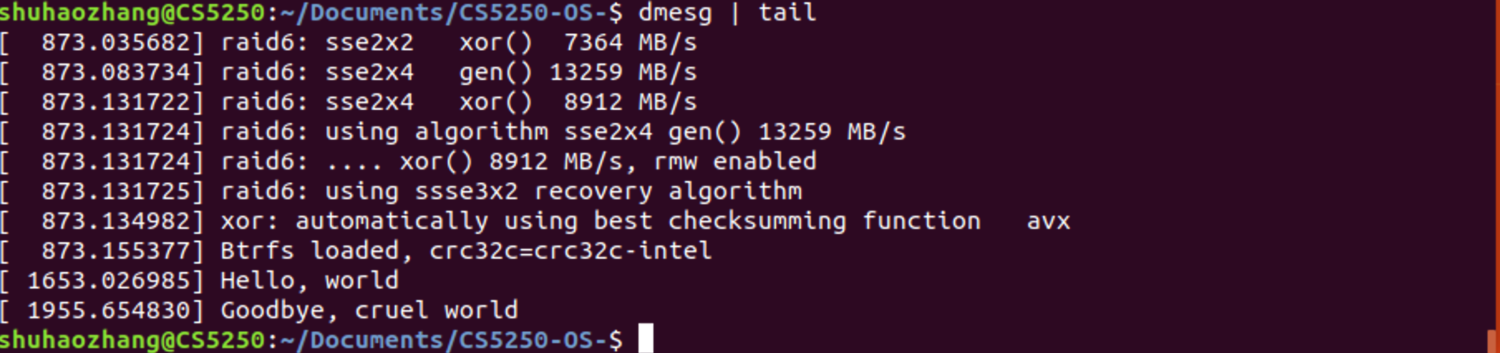

1. Add a <who> parameter to your module so that your module will show hello <who> during init stage.
2. Parameters are declared with the module_param macro, which is defined in moduleparam.h. I highlight the changes in red as follows.

#include <linux/kernel.h>

#include <linux/init.h>

#include <linux/module.h>

#include <linux/moduleparam.h> //for module_param

MODULE_LICENSE("GPL");

static char *who = "world";

module_param(who, charp, S_IRUSR|S_IWUSR);

MODULE_PARM_DESC(who, "Tell me your name.");

static int hello_init(void) {

printk(KERN_ALERT "Hello, %s!\n", who);

return 0;

}

static void hello_exit(void) {

printk(KERN_ALERT "Goodbye, %s\n",who);

}

module_init(hello_init);

module_exit(hello_exit);

1. lsmod call needs to be updated as well.

insmod ./$(TARGET_MODULE).ko who=$(who)

I test it with “sudo make load who=``SHUHAOZHANG”, “sudo make unload”. I clean dmesg first by **dmesg –c** The following screens shot shows the results of **dmesg**.

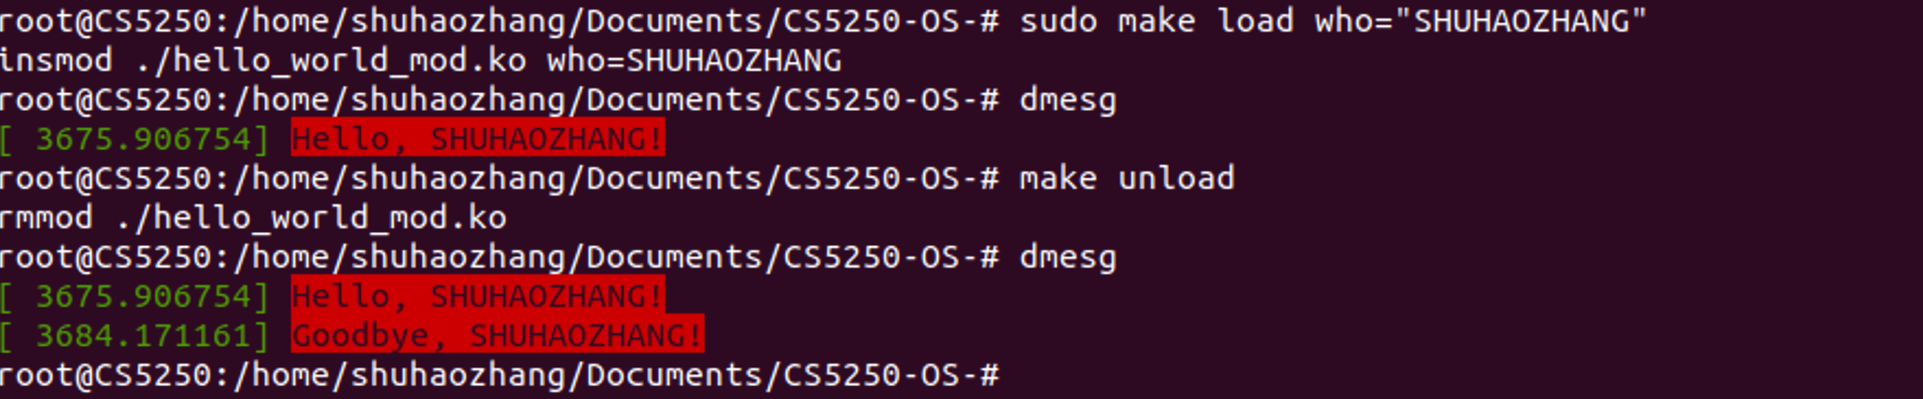

## Question 2:

1. Give the mknod command you use.

``sudo mknod /dev/chardev c **245** 0”. Note that, I use dynamic assigning major version instead of fixing at 61, which avoids potential conflict with other device drivers.

1. Give the screenshot of your device with “ls -l /dev” command and highlight your device. 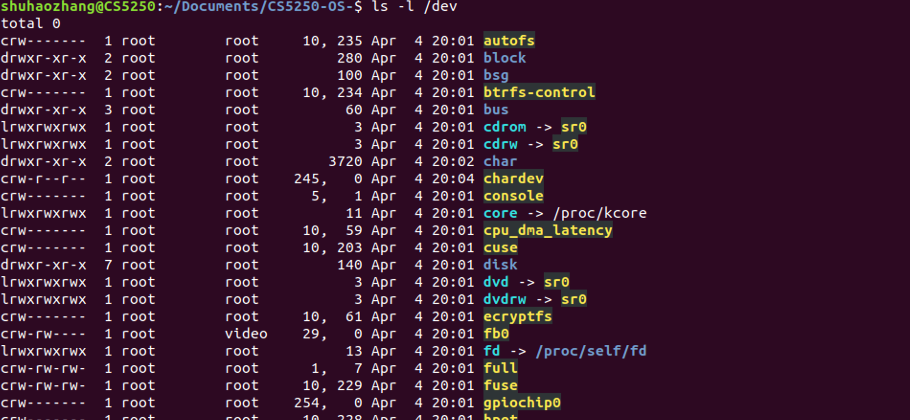
2. Give the codes of read and write functions that you implemented and the screenshots of the four testing cases.

**READ:**

ssize_t onebyte_read(struct file *filep, char *buf, size_t count, loff_t *f_pos)

{

/*please complete the function on your own*/

int bytes_read = 0;

/* Check if the buffer has been written */

if(*buf != 0){

return 0;

}

copy_to_user(buf, onebyte_data, sizeof(char));

bytes_read ++;

return bytes_read;

}

**WRITE:**

ssize_t onebyte_write(struct file *filep, const char *buf, size_t count, loff_t *f_pos)

{

/*please complete the function on your own*/

/**

* copy_from_user: Returns number of bytes that could not be copied. On success, this will be zero.

*

* to

* Destination address, in kernel space.

*

* from

* Source address, in user space.

*

* Number of bytes to copy.

*/

int bytes_write=0;

copy_from_user(onebyte_data, buf, sizeof(char));

/* Check the length of the bytes that cannot be written*/

if(count> sizeof(char))

{

printk(KERN_ALERT "No space left on device\n");

/*Return Linux System Error<28>: No space left on device */

return -ENOSPC;

}

bytes_write++;

return bytes_write;

}

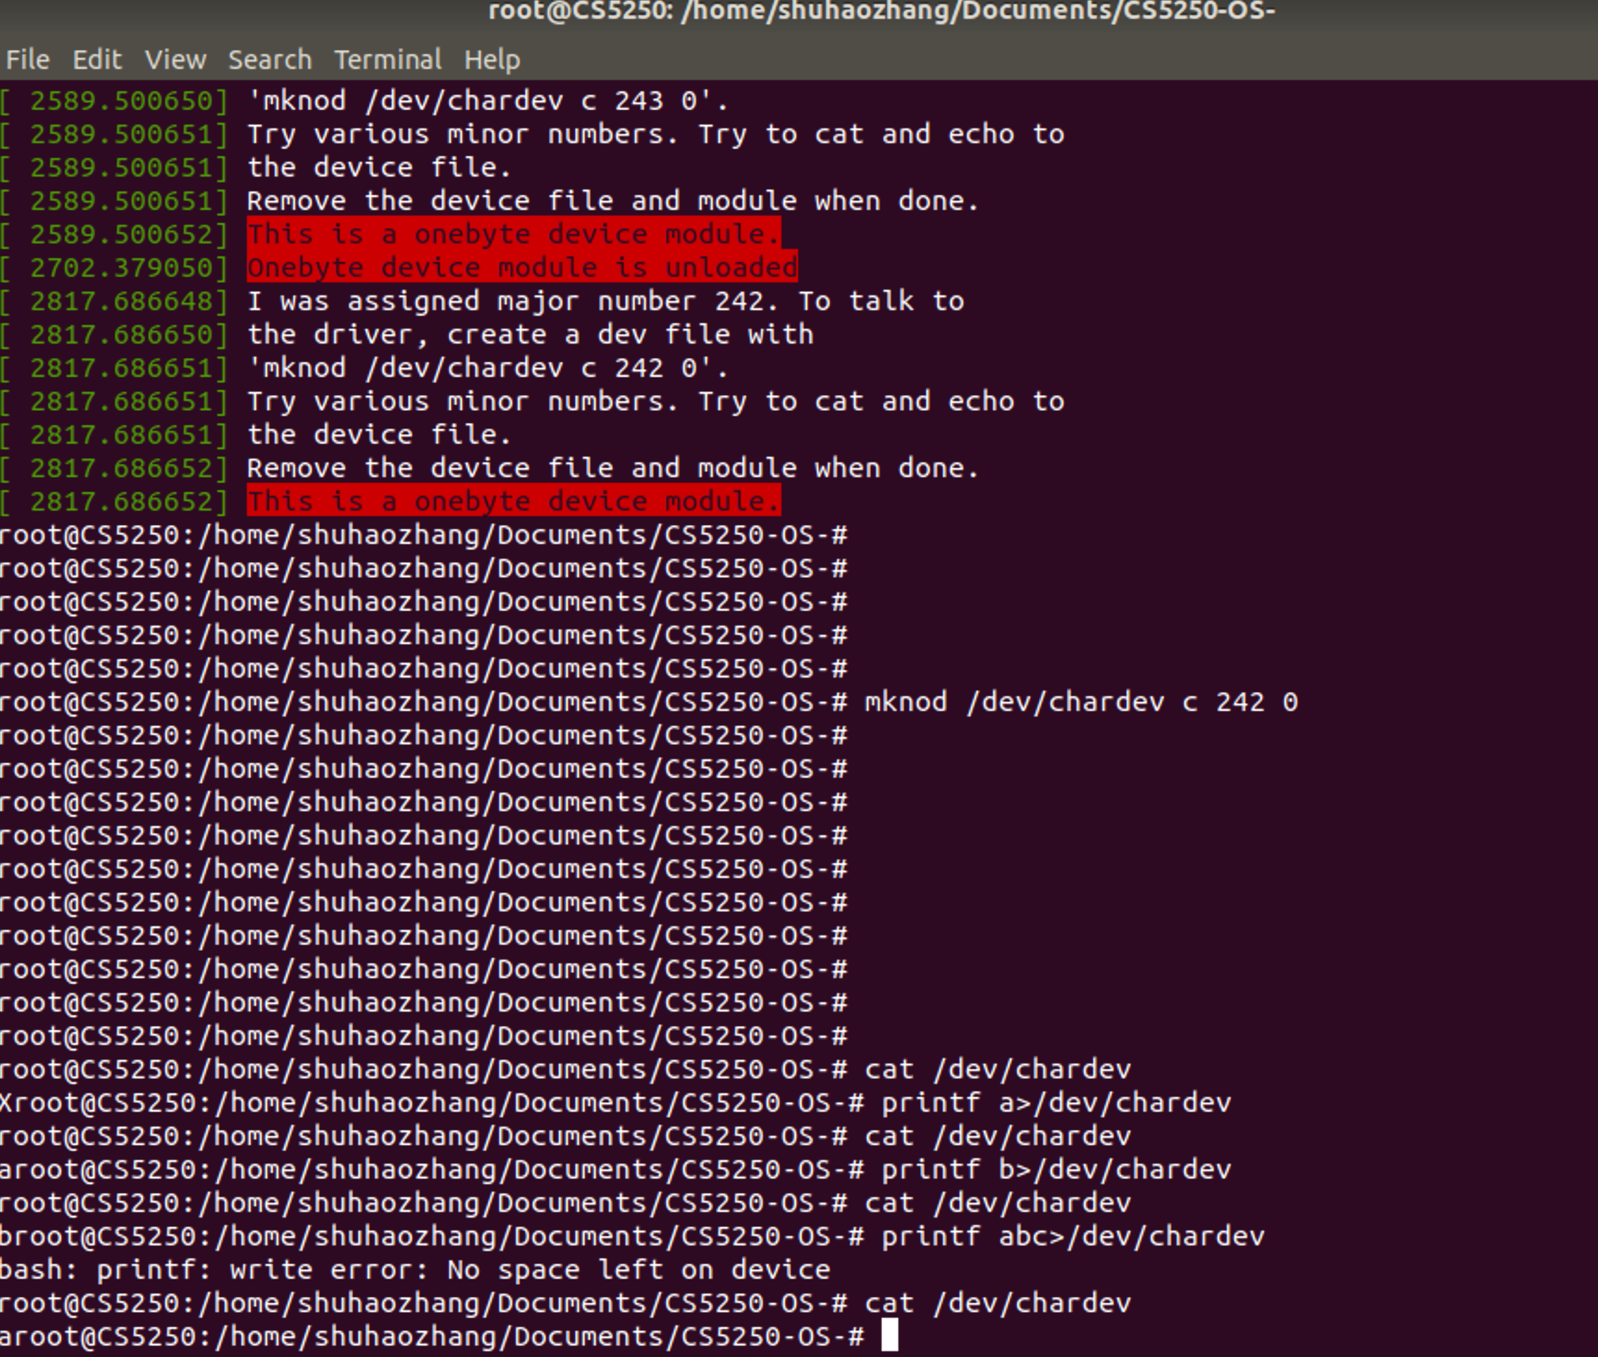

The following is the screenshot of github commit. The last two commit is made inside the virtual machine.

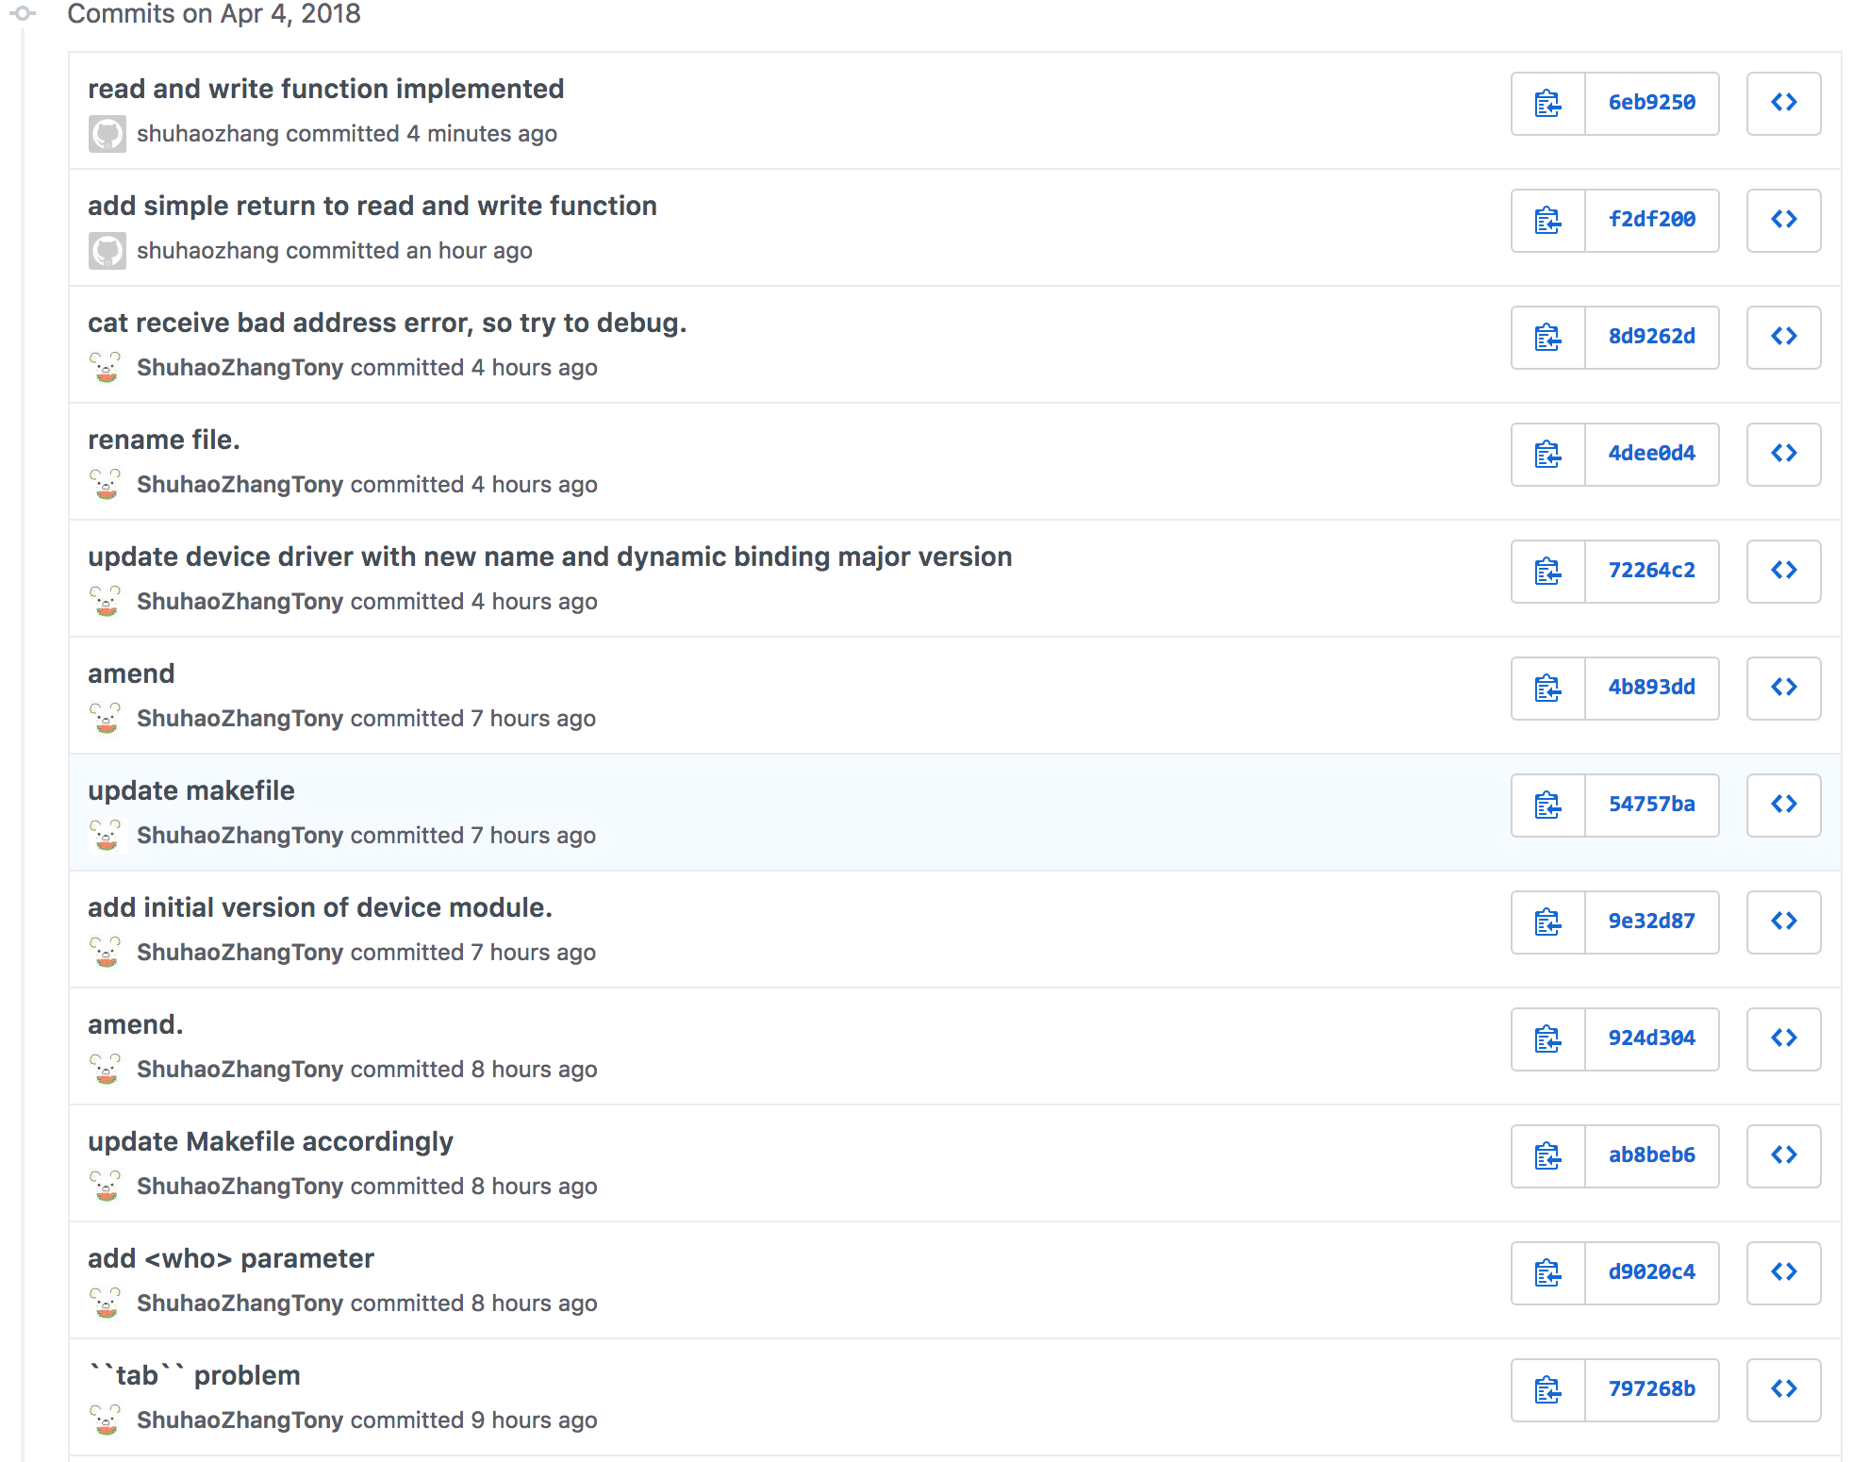

APPENDIX

The following are the source code I used in this project, I have highlighted the changes or important code lines in red.

**Chardev.c**

#include <linux/module.h>

#include <linux/kernel.h>

#include <linux/init.h>

#include <linux/slab.h>

#include <linux/errno.h>

#include <linux/types.h>

#include <linux/fs.h>

#include <linux/proc_fs.h>

#include <asm/uaccess.h>

#include <linux/uaccess.h>

#define MAJOR_NUMBER 61/* forward declaration */

static int Major; /* Major number assigned to our device driver */

#define DEVICE_NAME "chardev" /* Dev name as it appears in /proc/devices */

int onebyte_open(struct inode *inode, struct file *filep);

int onebyte_release(struct inode *inode, struct file *filep);

ssize_t onebyte_read(struct file *filep,

char *buf, size_t count,

loff_t *f_pos);

ssize_t onebyte_write(struct file *filep,

const char *buf, size_t count,

loff_t *f_pos);

static void onebyte_exit(void);

/* definition of file_operation structure */

struct file_operations onebyte_fops = {

read: onebyte_read,

write: onebyte_write,

open: onebyte_open,

release: onebyte_release

};

char *onebyte_data = NULL;

/*

* Called when a process tries to open the device file, like

* "cat /dev/mycharfile"

*/

int onebyte_open(struct inode *inode, struct file *filep)

{

return 0; // always successful

}

int onebyte_release(struct inode *inode, struct file *filep)

{

return 0; // always successful

}

ssize_t onebyte_read(struct file *filep, char *buf, size_t count, loff_t *f_pos)

{

/*please complete the function on your own*/

int bytes_read = 0;

/* Check if the buffer has been written */

if(*buf != 0){

return 0;

}

copy_to_user(buf, onebyte_data, sizeof(char));

bytes_read ++;

return bytes_read;

}

ssize_t onebyte_write(struct file *filep, const char *buf, size_t count, loff_t *f_pos)

{

/*please complete the function on your own*/

/**

* copy_from_user: Returns number of bytes that could not be copied. On success, this will be zero.

*

* to

* Destination address, in kernel space.

*

* from

* Source address, in user space.

*

* n

* Number of bytes to copy.

*/

int bytes_write=0;

copy_from_user(onebyte_data, buf, sizeof(char));

/* Check the length of the bytes that cannot be written*/

if(count> sizeof(char))

{

printk(KERN_ALERT "No space left on device\n");

/*Return Linux System Error<28>: No space left on device */

return -ENOSPC;

}

bytes_write++;

return bytes_write;

}

static int onebyte_init(void)

{

// int result;

// register the device

Major = register_chrdev(0, DEVICE_NAME, &onebyte_fops);

if (Major < 0) {

printk(KERN_ALERT "Registering char device failed with %d\n", Major);

return Major;

}

printk(KERN_INFO "I was assigned major number %d. To talk to\n", Major);

printk(KERN_INFO "the driver, create a dev file with\n");

printk(KERN_INFO "'mknod /dev/%s c %d 0'.\n", DEVICE_NAME, Major);

printk(KERN_INFO "Try various minor numbers. Try to cat and echo to\n");

printk(KERN_INFO "the device file.\n");

printk(KERN_INFO "Remove the device file and module when done.\n");

// allocate one byte of memory for storage

// kmalloc is just like malloc, the second parameter is// the type of memory to be allocated.

// To release the memory allocated by kmalloc, use kfree.

onebyte_data = kmalloc(sizeof(char), GFP_KERNEL);

if (!onebyte_data) {

onebyte_exit();

// cannot allocate memory

// return no memory error, negative signify a failure

return -ENOMEM;

}

// // initialize the value to be X

*onebyte_data = 'X';

printk(KERN_ALERT "This is a onebyte device module.\n");

return 0;

}

static void onebyte_exit(void)

{

// if the pointer is pointing to something

if (onebyte_data) {

// free the memory and assign the pointer to NULL

kfree(onebyte_data);

onebyte_data = NULL;

}

// unregister the device

unregister_chrdev(MAJOR_NUMBER, DEVICE_NAME);

printk(KERN_ALERT "Onebyte device module is unloaded\n");

}

MODULE_LICENSE("GPL");

module_init(onebyte_init);

module_exit(onebyte_exit);

**Makefile**

TARGET_MODULE:=chardev

obj-m += $(TARGET_MODULE).o

all:

make -C /lib/modules/$(shell uname -r)/build M=$(PWD) modules

clean:

make -C /lib/modules/$(shell uname -r)/build M=$(PWD) clean

load:

insmod ./$(TARGET_MODULE).ko

unload:

rmmod ./$(TARGET_MODULE).ko

**Hello_world_mod**

#include <linux/kernel.h>

#include <linux/init.h>

#include <linux/module.h>

#include <linux/moduleparam.h> //for module_param

MODULE_LICENSE("GPL");

static char *who = "world";

module_param(who, charp, S_IRUSR|S_IWUSR);

MODULE_PARM_DESC(who, "Tell me your name.");

static int hello_init(void)

{

printk(KERN_ALERT "Hello, %s!\n", who);

return 0;

}

static void hello_exit(void)

{

printk(KERN_ALERT "Goodbye, %s!\n", who);

}

module_init(hello_init);

module_exit(hello_exit);

**Makefile**

TARGET_MODULE:=hello_world_mod

obj-m += $(TARGET_MODULE).o

all:

make -C /lib/modules/$(shell uname -r)/build M=$(PWD) modules

clean:

make -C /lib/modules/$(shell uname -r)/build M=$(PWD) clean

load:

insmod ./$(TARGET_MODULE).ko who=($who)

unload:

rmmod ./$(TARGET_MODULE).ko